A Histogram based New Approach of Eye Detection for Face Identification

Abstract

Eye detection is the most important and critical task of face detection. In this paper, we propose a new approach of eye detection by using gray histograms in eye candidate regions. We conducted our experiment with the 3500 face images which are captured from CCD camera under the varying condition of illumination, pose, and expression.
From the experiment result, it is shown that our approach is better than VPF based eye detection algorithm in detection time and accuracy.

Keywords: eye detection, face mask image, histogram smoothing

1. Introduction

Face recognition is a field of biometrics together with fingerprint recognition, iris recognition, and speech recognition and so on. Automatic extraction of human head, face boundaries, and facial features is critical in the areas of face recognition, criminal identification, security, surveillance systems, human computer interfacing, and model-based video coding. In general, the computerized face recognition includes four steps [1]. First, the face image is enhanced and segmented. Second, the face boundary and facial features are detected. Third, the extracted features are matched against the features in the database. Fourth, the classification into one or more persons is achieved.
In order to detect faces and find the facial features correctly, researchers have proposed a variety of methods which can be divided into two categories. One is based on gray-level template matching, and the other is based on computation of geometric relationship among facial features.
Face detection is the most important part of face identification and it is difficult due to varying of illumination, pose of head, and face expression.[1]
Eye detection is also the most important and critical task of face detection[2,3,4]. In this paper, we propose a new approach of eye detection using gray histograms in eye candidate regions. Our eye detection algorithm works on face region determined by the method presented in [5].
This paper is organized as follows. Section 2 describes the extraction of face mask image. Section 3 describes the eye region image extraction based on the geometric face model and face mask image. Section 4 describes eye localization using horizontal and vertical histogram of eye region image. Section 5 describes our experimental results in comparison with VPF based eye detection approach[3]. Conclusions are made in Section 5.

2. Extraction of Face Mask Image

This phase is a first part of preprocessing of eye detection algorithm.
Fig-1 shows block diagram of face mask image extraction.

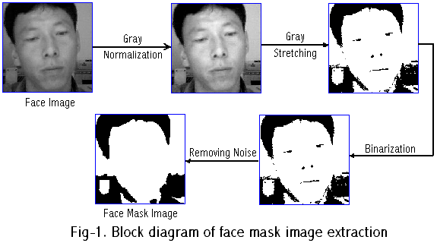

2.1 Gray Normalization

Given input gray image$I(i, j)$, normalized image $I^{'}(i, j)$ is computed by the following equation.
$I^{'}(i, j)=\begin{aligned}\left\{M_{0}+\sqrt{\frac{V_{0}⋅{\left(I(i, j)−M\right)}^{2}}{V}}, I(i, j)>M | \right.\end{aligned}$ (1)
Where,
$M, V$ : mean value and variance of inputted imager $I(i, j)$
$M_{0}, V_{0}$ : mean value and variance of destination image $I^{'}(i, j)$

4.2 Gray Stretching

Given $M_{I}$ , mean value of gray normalized image$I(i, j)$, gray stretched image $I^{'}(i, j)$ is computed by the following equation (2).
$I^{'}(i, j)=\begin{aligned}\left\{0 ,I(i, j)<I_{\text{min}} | \right.\left\{\text{255}, ,I(i,j)>I_{\text{max}} | \right.\end{aligned}$ (2)

where, $I_{\text{max}}={M_{I}⋅P_{0}}/{\text{100}}, I_{\text{min}}={M_{i}⋅P_{1}}/{\text{100}}$

4.3 Binarization and Removing Noise

In binarization phase, we use mean value of gray stretched image.
In removing noise phase, when the pixel number of white spots in black region and one of black spots in white region are less than $T_{S}$, we remove all them.

3. Extraction of Eye Region Image

Here, we apply the face mask image (binary image) to gray face image, then extract eye region image. Given binary face mask image $I_{M}\left\{i,j\right\}$, input gray face image $I(i, j)$, $R_{L}$and$R_{R}$, two eye regions obtained by mean values of the method [4] two eye region image $I_{L}, I_{R}$ are computed by the following equations.
$I_{L}(x, y)=\begin{aligned}\left\{I(x, y), (x, y)∈R_{L}∧I_{M}(x, y)=\text{255} | \right.\end{aligned}$ (3)
$I_{R}(x, y)=\begin{aligned}\left\{I(x, y), (x, y)∈R_{R}∧I_{M}(x, y)=\text{255} | \right.\end{aligned}$ (4)

4. Eye Localization

Here, first, we apply gray normalization and 3*3 smoothing to eye region images and second, we calculate horizontal and vertical projection histogram of them. Finally, we apply Gaussian mask to them and fourth localize two eyes.

4.1 Estimation of y-coordinates of two eyes

We calculate vertical projection histogram of two eye regions$R_{L}, R_{R}$ by the following equations.
$H_{L}^{V}(y)=\sum_{(x, y)∈R_{L}}{{\left(\text{255}−I_{L}(x, y)\right)}^{2}}$ (5)
$H_{R}^{V}(y)=\sum_{(x, y)∈R_{R}}{{\left(\text{255}−I_{R}(x, y)\right)}^{2}}$ (6)

Next, we apply Gaussian mask of which length is 9 to$H_{L}^{V}, H_{R}^{V}$, respectively.
In Fig-3, an example of histogram smoothing is shown.
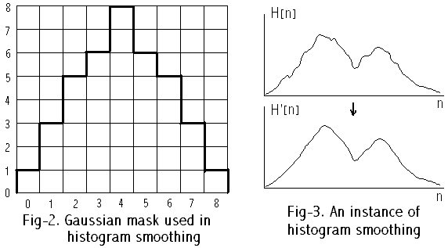
As shown in Fig-3, there are two peaks according to eyebrow region and eye region. We select the position of second peak as y-coordinate of eye(center of pupil).

4.2 Estimation of x coordinates of two eyes

Denote y-coordinates of two eyes estimated above by $y_{L}$and$y_{R}$, respectively. Then, we calculate horizontal projection histogram of two eye regions $R_{L}, R_{R}$ by the following two equations, respectively.
$H_{L}^{H}(x)=\sum_{y=y_{L}−W_{L}}^{y_{L}+W_{L}}{{\left(\text{255}−I_{L}(x, y)\right)}^{2}}$ (7)
$H_{R}^{H}(x)=\sum_{y=y_{R}−W_{R}}^{y_{R}+W_{R}}{{\left(\text{255}−I_{R}(x, y)\right)}^{2}}$ (8)
where, $W_{L}$ and $W_{R}$are diameters of left and right pupil which are associated experimentally.
Next, we apply above Gaussian mask to $H_{L}^{H}$ and $H_{R}^{H}$respectively and we select the position of first peak as x coordinate of eye (center of pupil).

5. Experimental result

Thresholds of eye detection algorithm in our experiment are as follows.

$M_{0}=\text{120}, V_{0}=\text{70}, P_{0}=\text{60}, P_{1}=\text{70}, T_{S}=\text{180}, W_{L}=W_{R}=8$ (9)

We conducted our experiment with 3500 face images which are captured from CCD camera (Logitech) under the varying condition of illumination, pose of head and expression of face. Computer used in experiment is Pentium III(CPU 650 MHz, Memory 128MB). Table.1 and Table.2 shows the comparison results of detection time and detection rate between our approach and proceeding approach [3] on our specific database. Fig.4 shows two examples of eye detection results.

Item  Method | Mean value Detection Time
Method [3] | 24 ms
Our method | 18 ms

Table.1 A comparison result of mean value face detection time

Item  Method | Detection Rate | False Detection Rate
Method [3] | 98.25% | 1.75%
Our method | 99.33% | 0.67%

Table 2. A comparison result of mean value face detection rate

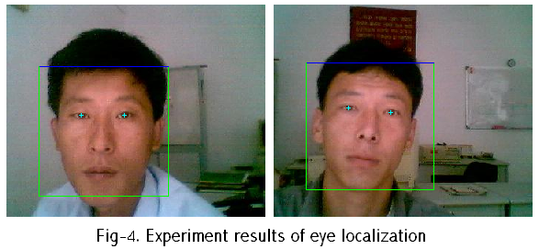

6. Conclusion

In this paper, we presented a new approach of eye detection by using gray histograms in eye candidate regions. From the result, it is shown that our approach is better than VPF based eye detection algorithm in detection time and accuracy. The full eye detection algorithm on any rotated face image will be our future task.

References

[1] M. H. Yang et al, “Detecting Faces in Images : A Survey”, IEEE trans. on PAMI. 24(1), 34-59.
[2] G. C. Feng et al, “Multi-cues eye detection on gray intensity image”, Pattern Recognition 34(5), 1033-1046..
[3] G. C. Feng et al, “Variance projection and its application to eye detection for face recognition”, Pattern Recognition Letters 19, 899-906.
[4] C. C. Chiang et al, “A novel method for detecting lips, eyes and faces in real time”, Real-Time Imaging, 9, 2003.
[5] Li Song Jin. “A method of face detection using geometrical structure of human face”, Kuahakwontongbo(Bulletin of natural science of Academy of Science of D. P. R of Korea) 51(1) 21-26.

